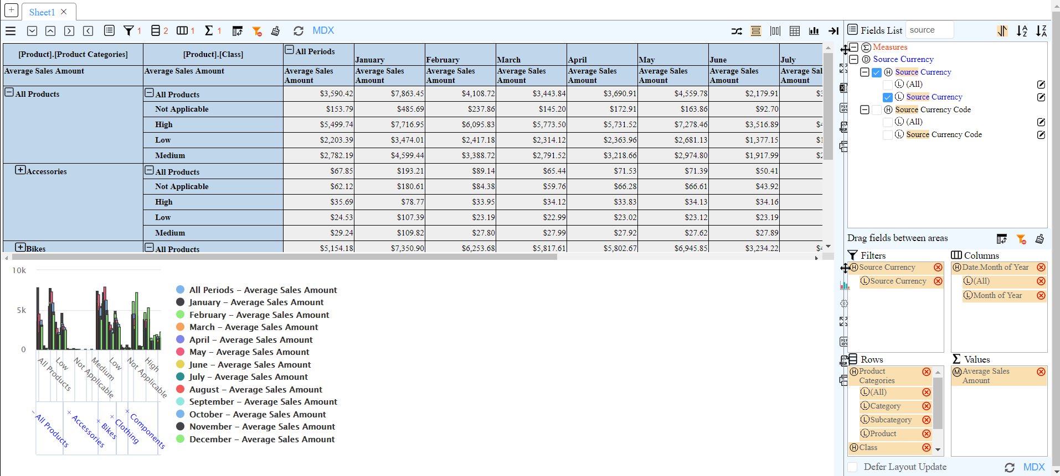

The page loads this error every time I add a filter

Further steps: Select labels from Source Label and choose US Dollar and Canadian Dollar